
Company
Logotype

Cone Beam Computed Tomography- Report



Porur Dental X-rays & CBCT

Patient Name : Mr. Vidyut | Date of Report : 04.03.2024
Age/ Gender : 13 years/ Male | Region of Interest : CBCT Full Skull
Referring doctor: Dr. Karthikeyan | Indication : Impacted teeth
Clinical Notes: Nil
PATIENT INFORMATION

CBCT Full Skull provided
CBCT – IMAGE DETAILS

RADIOGRAPHIC INTERPRETATION

- No of teeth (erupted) present in the maxillary and mandibular alveolar ridge: 28
- No of teeth present in the maxillary and mandibular alveolar ridge in total: 34
- Deciduous teeth: 53, 63;
- The tooth 13, 23 appears to be within the alveolar bone, distally tipped and lies above the periapical aspect of the deciduous teeth 53 and 63 respectively.
- The radicular portion of 13, 23 lies in proximity to the medial wall of right and left maxillary sinus respectively.
- The labial surface of 13 and 23 lie involving the labial cortical bone.
- The crown of 23 appears to be in close proximity to the radicular portion of 22.

- Developing crowns of 18, 28, 38, 48.
- Distance between the alveolar ridge and 13: 2.84 mm
- Width of Palatal cortical bone in relation to 13: 1.86 mm
- Distance between the alveolar ridge and 23: 4.6 mm
- Width of Palatal cortical bone in relation to 13: 2.49 mm

RADIOGRAPHIC IMPRESSION


- Retained deciduous teeth: 53, 63.
- Permanent successor: 13, 23

IMAGES FOR REFERENCE

PANORAMA VIEW
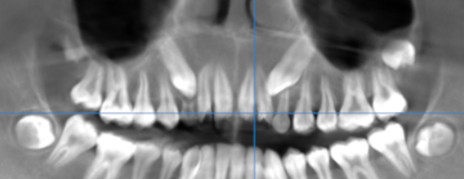
CROSS- SECTIONAL IMAGES
13 REGION | 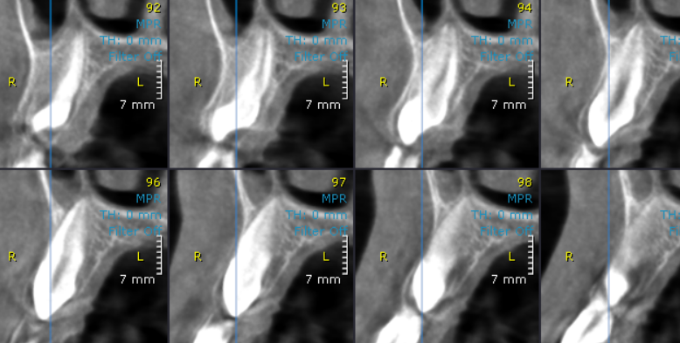
23 REGION | 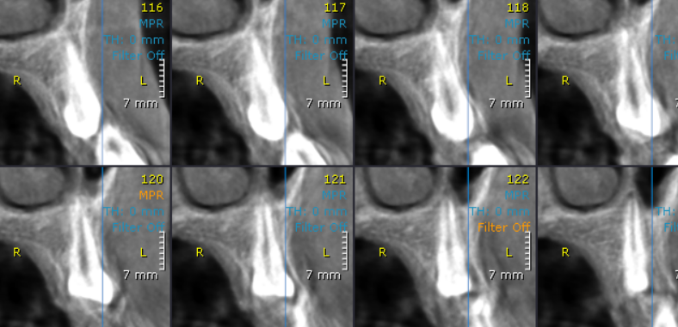

3-DIMENSIONAL VIEW

Tooth: 13
Tooth 23
Developing crown 18

Developing crown 28
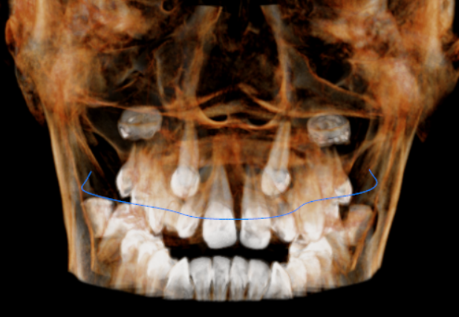

Deciduous tooth : 63
Deciduous tooth : 73

**** End of report ****

